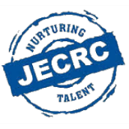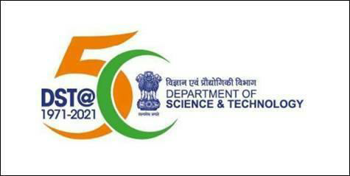

**Department of Science & Technology**

**(Government of India)**

**Sponsored**

**Technical Entrepreneurial Development Program**

**Robotics and Process Automation (RPA)**

**Inauguration Program**

**2021@ to a.m.**

**Inauguration Program Schedule**

|  |  |  |  |
| --- | --- | --- | --- |
| **S. No.** | **Event** | **Person** | **Time** |
| 1. | Welcome Note |  |  |
| 2. | Welcome Address by Principal JECRC |  |  |
| 3. | Address by Honored Guest | i |  |
| 4. | Introduction of the event |  |  |
| 5. | Vote of Thanks |  |  |
| 6. | End of Inauguration |  |  |